Project Name: Inpatient Rehab (IPRehab)

Business POC: Bidelspach, Douglas

Team: Chun Jonathan Sun (Web app)

Scott Dieffenbach (Database/IIS configuration)

Web URL’s:

Production Web App: <https://vaww.vssc.med.va.gov/IPRehabMetrics>  
Production WebAPI Service: <https://vaww.vssc.med.va.gov/IPRehabMetricsWebAPI/Swagger>  
Test Web App: <https://vhaausweb3.vha.med.va.gov/IPRehabMetrics>  
Test WebAPI Service: <https://vhaausweb3.vha.med.va.gov/IPRehabMetrics>WebAPI/Swagger

Folders for source code: NA

TFS location:

Collection name: WebApps

Project name: RehabMetricsAndOutcomes

Locations:

|  |  |  |  |
| --- | --- | --- | --- |
| **Web App** | **Development** | URL | <https://VhaAusWeb3.vha.med.va.gov/IPRehabMatrics> |
| UNC | \\VhaAusWeb3.vha.med.va.gov\webapplications\IPRehabMetrics |
| **Test** | URL |  |
| UNC | \\VhaAusWeb3.vha.med.va.gov\IPRehabMetricsTEST |
| **Web API** | **Production** | URL | <https://VaWW.vssc.med.va.gov/IPRehabmetrics> |
| UNC | \\VhaAusW7.vha.med.va.gov\webapplictions\IPRehabMetricsWebAPI |
| **Test** | UNC | \\VhaAusWeb3.vha.med.va.gov\IPRehabMetricsWebAPITEST |

Publishing to webserver process (Visual Studio 2019):

* Clone or Open existing cloned solution (<path to workspace>\IPRehab.sln)
* Optional: manually restore Nuget package
* Optional: open command line prompt and CD to the project folder where package.json resides and manually restore Node package by executing 

From menu select Build Solution   
  
If failed, build each project independently in the following order

* IPRehabModel
* PatientModel
* IPRehabRepository
* IPRehabWebAPI2
* IPRehab

From menu select Publish IPRehab  
  
In the ensuing tab, select the VHAAUSWeb3 (DEV) from .pubxml profile dropdown for testing deployment, or the VHAAUSWeb7 (PROD) for production deployment.  
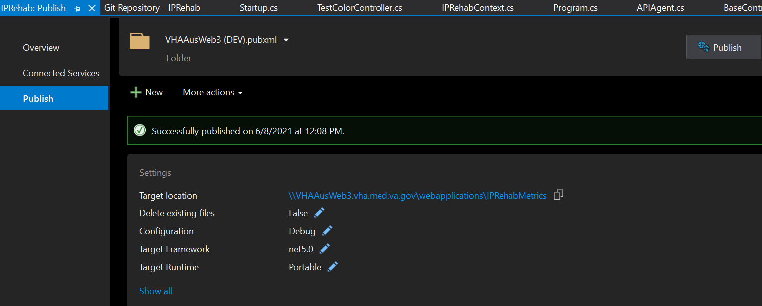

From menu select Publish IPRehabWebAPI2  
In the ensuing tab, select VHAAUSWeb3 from the .pubxml profile dropdown for testing deployment, or the VHAAUSWeb7 (PROD) for production deployment.

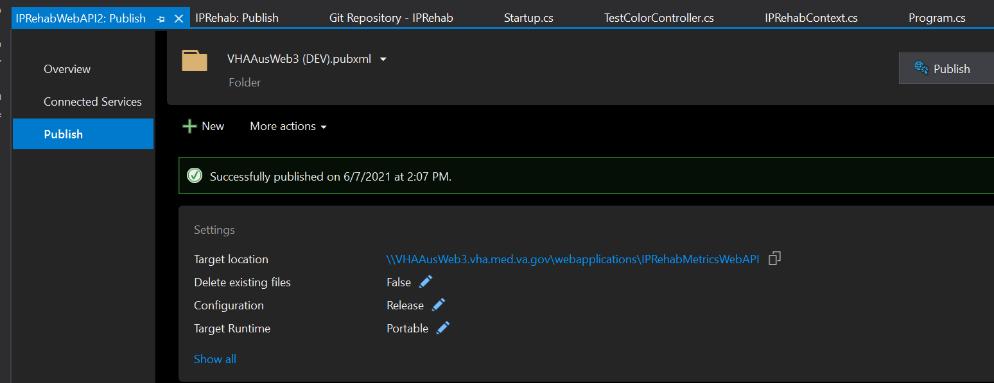

Notes: